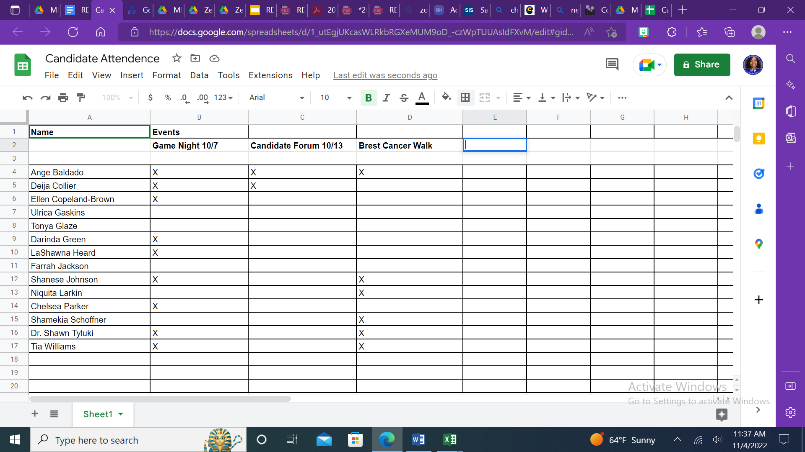

[Click Here for Updated 2022 Candidates](https://docs.google.com/presentation/d/1k3DnuuB5euhOf5b1--k5Yc7iqrIyrKEkfH447wSOB7k/edit?usp=sharing)